Book Name: TEXTBOOK OF SOCIOLOGY FOR PHYSIOTHERAPY STUDENTS  - Print length ‏ : ‎ 191 pages  - ISBN:9789376862016  - ISBN-10 ‏ : ‎ 9376862015  - ISBN-13 ‏ : ‎ 978-9376862016  Importance of the book:  - Covers physiotherapy syllabus as per Indian universities, ensuring exam relevance  - Includes case studies, illustrations, and practical examples for better understanding  - Explains social and cultural factors affecting patient health and recovery  - Written in clear, student-friendly language for easy comprehension  - Enhances patient communication and holistic care approach  Procurement link:  - Amazon: https://www.amazon.in/dp/9376862015  - Flipkart: https://www.flipkart.com/product/p/itme?pid=9789376862016  - Astitva Store: https://astitvaprakashan.com/?post_type=product&p=10216&preview=true  - Classic Shelf: https://classicshelf.in/products/textbook-of-sociology-for-physiotherapy-students-ncahp-2025-curriculum-compliant | 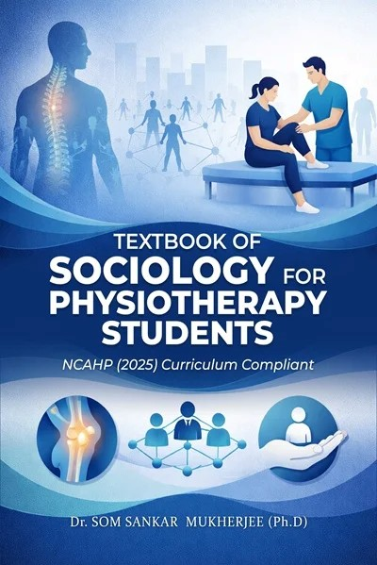

Book Name: Textbook of Psychology for Physiotherapy students  - Print length ‏ : ‎ 340 pages  - ISBN: 9789376868810  - ISBN-10 ‏ : ‎ 9376868811  - ISBN-13 ‏ : ‎ 978-9376868810  Importance of the book:  - Aligned with latest NCAHP curriculum, ensuring academic relevance for physiotherapy students  - Integrates psychological concepts with clinical physiotherapy practice for better application  - Uses simple language with examples, charts, and illustrations for easy learning  - Covers comprehensive topics to build strong theoretical foundation  - Helps improve patient interaction, behavior understanding, and treatment outcomes  Procurement link:  - Amazon: https://www.amazon.in/dp/9376862015  - Flipkart: https://www.flipkart.com/product/p/itme?pid=9789376862016  - Astitva Store: https://astitvaprakashan.com/?post_type=product&p=10216&preview=true  - Classic Shelf: https://classicshelf.in/products/textbook-of-sociology-for-physiotherapy-students-ncahp-2025-curriculum-compliant | 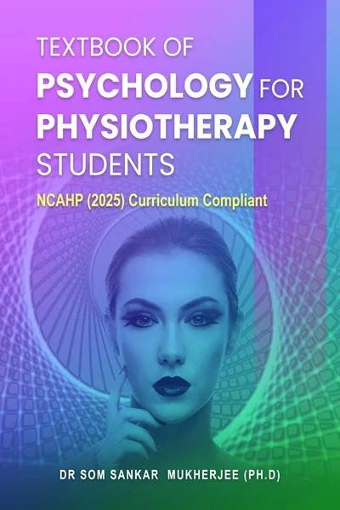

Book Name: Pedagogy in Physiotherapy: Theories and Practices  - Print length ‏ : ‎ 274 pages  - ISBN: 9789374245941  - ISBN-10 ‏ : ‎ 9374245949  - ISBN-13 ‏ : ‎ 978-9374245941  Importance of the book:  - Provides comprehensive understanding of teaching methods in physiotherapy education  - Bridges theory with practical teaching strategies for clinical and academic settings  - Covers pedagogy concepts aligned with university-level curriculum  - Useful for postgraduate students, educators, and academic professionals  - Enhances teaching effectiveness and student learning outcomes in physiotherapy  Procurement link:  Crown Publishers: https://bookscamel.in/app/views/shop-details.php?id=1355  Amazon: https://www.amazon.in/Pedagogy-Physiotherapy-Practices-Curriculum-Compliant/dp/9374245949/ref=sr_1_1?crid  Flipkart: https://www.flipkart.com/pedagogy-physiotherapy-theories-practices-ncahp-2025-curriculum-compliant/p/itm742da9f7100e1?pid  Books Camel:  https://bookscamel.in/app/views/shop-details.php?name=pedagogy-in-physiotherapy-theories-and-practices&q=MTM1NQ | 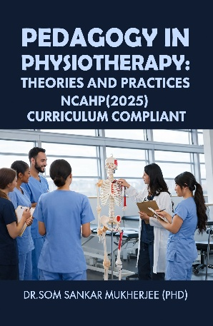

Book Name: MANAGEMENT AND ADMINISTRATION IN PHYSIOTHERAPY PRACTICE  - Print length ‏ : ‎ 218 pages  - ISBN:9789374241431  - ISBN-10 ‏ : ‎ 9374241439  - ISBN-13 ‏ : ‎ 978-937424143  Importance of the book:  - Covers essential topics like planning, staffing, budgeting, and quality control in physiotherapy services  - Builds practical management and administrative skills for clinics and hospitals  - Integrates healthcare management principles with physiotherapy practice  - Helps understand leadership, communication, and team coordination  - Prepares students for real-world clinical and organizational responsibilities  Procurement link:  https://bookscamel.in/app/views/shop-details.php?id=1352  Amazon:  https://www.amazon.in/Management-Administration-Physiotherapy-Practice-Curriculum/dp/9374241439/ref=sr_1_1?crid  Flipkart: https://www.flipkart.com/management-administration-physiotherapy-practice-ncahp-2025-curriculum-compliant/p/itmee13219fec5a4?pid  Books Camel:  https://bookscamel.in/app/views/shop-details.php?name=management-and-administration-in-physiotherapy-practice&q=MTM1Mg | 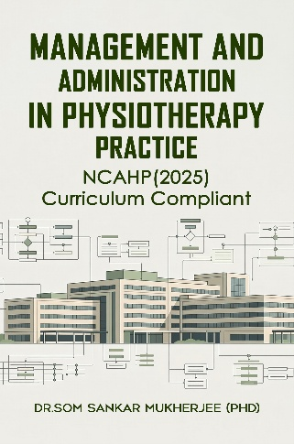

Book Name: FOUNDATIONS OF ETHICS AND PROFESSIONALISM IN PHYSIOTHERAPY PRACTICE  - Print length ‏ : ‎ 228 pages  - ISBN: 9789374244210  - ISBN-10 ‏ : ‎ 9374244217  - ISBN-13 ‏ : ‎ 978-9374244210  Importance of the book:  - Covers core ethical principles, professional conduct, and legal aspects in physiotherapy practice  - Bridges theory with real-life clinical application for better decision-making  - Emphasizes accountability, integrity, and patient-centered care values  - Includes topics like professional relationships, standards, and evidence-based practice  Helps develop strong professional identity and ethical awareness for future practice  Procurement link:  Amazon:  https://www.amazon.in/Foundations-Ethics-Professionalism-Physiotherapy-Practice/dp/9374244217/ref=sr_1_1?crid  Flipkart:  https://www.flipkart.com/foundations-ethics-professionalism-physiotherapy-practice-ncahp-2025-curriculum-compliant/p/itm9ca6a516f44c0?pid  Books Camel:  https://bookscamel.in/app/views/shop-details.php?id=1354 | 